Ian Lim Ee Khai

P21013175

4001CEM

Task 3 - Class diagram and design pattern

4001CEM 2021 Assignment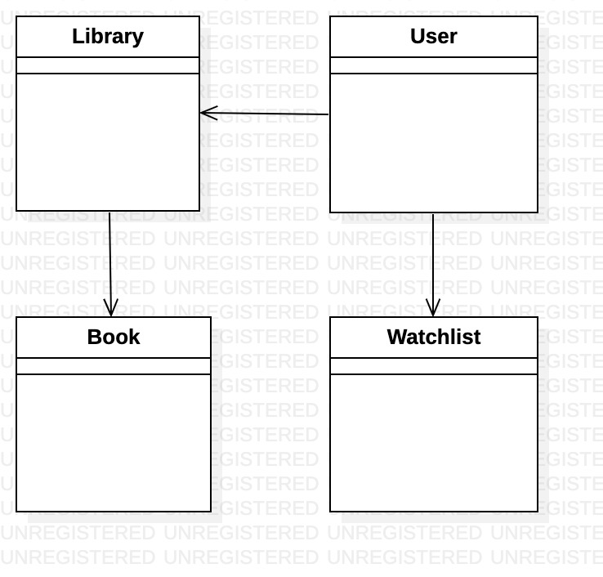

The user class is creates an object that handles all user-related data, such as storing and changing email, password, as well as the library and watchlist classes. Library objects are linked to a single user, and are used to store all the books that the particular user has put up to trade. The book class is used as a template to generate books to put up for trading. All books are stored in a library. The watchlist is another object linked to a specific user, and keeps track of all the books that a user wants to trade for from another user.

The observer interface is implemented to design the system for notifying users on the state of a book that they are looking to trade for. The publisher class keeps track of all the subscribers and what they are offering as a trade, as well as adding and removing subscribers. When an event occurs, such as the book being traded or taken down, the publisher will call a notification method on the subscriber interface on every subscriber object. The subscriber objects will display a message depending on what notification method was called.

This design pattern was chosen as it defines a subscription mechanism that can notify multiple objects about any events that are occurring to the object they’re observing.